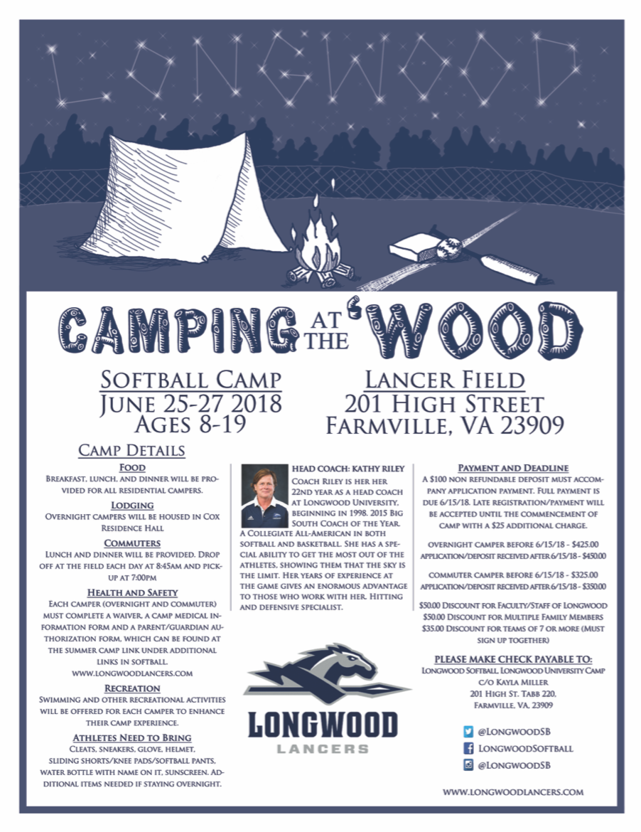



WWW.LONGWOODLANCERS.COM

All Longwood University camps and clinics are open to any and all entrants, and are only limited by the number, age, grade level or gender described.

HEAD COACH:

KATHY RILEY

COACH RILEY IS IN HER 23RD YEAR AS A HEAD COACH AT LONGWOOD UNIVERISTY. BEGINNING IN 1998. 2015 BIG SOUTH COACH OF THE YEAR. A COLLEGIATE ALL-AMERICAN IN BOTH SOFTBALL AND BASKETBALL. SHE HAS A SPECIEAL ABILITY TO GET THE BEST OUT OF THE ATHLETES, SHOWING THEN THE SKY IS THE LIMIT. HER YEARS OF EXPERIENCE AT THE GAME GIVES AN ENORMOUS ADVANTAGE TO THOSE WHO WORK WITH HER. HITTING AND DEFENSIVE SPECIALIST.

**C AMP DETAILS**

FOOD

BREAKFAST, LUNCH, AND DINNER WILL BE PROVIDED FOR ALL RESIDENTIAL CAMPERS.

LODGING

OVERNIGHT CAMPERS WILL BE HOUSED IN ARC RESIDENCE HALL

COMMUTERS

LUNCH AND DINNER WILL BE PROVIDED. DROP OFF AT FIELD EACH DAY AT 8:45AM AND PICK UP AT 7:00 PM

HEALTH AND SAFETY

EACH CAMPER (OVERNIGHT AND COMMUTER) MUST COMPLETE A WAIVER, A CAMP MEDICAL INSURANCE FORM AND A PARENT/GUARDIAN AUTHORIZATION FORM, WHICH CAN BE FOUND AT OUR CAMP WEBSITE.

www.totalcamps.com/LONGWOODSOFTBALL

RECREATION

SWIMMING AND OTHER RECREATIONAL ACTIVITIES WILL BE OFFERED FOR EACH CAMP TO ENHANCE THEIR CAMP EXPERIENCE

ATHLETES NEED TO BRING

CLEATS, SNEAKERS, GLOVE, HELMET, SLIDING SHORTS/SOFTBALL PANTS. WATER BOTTLE WITH NAME ON IT, SUNSCREEN. ADDITIONAL ITEMS NEEDED IF STAYING OVERNIGHT.



@LONGWOODSB

@LONGWOODSOFTBALL

@LONGWOODSB

LANCER FIELD

201 HIGH STREET

FARMVILLE, VA 23909

SOFTBALL CAMP

JUNE 24-26 2019

AGES 8-19

CAMPING ‘WOOD:

PART ii

AT THE

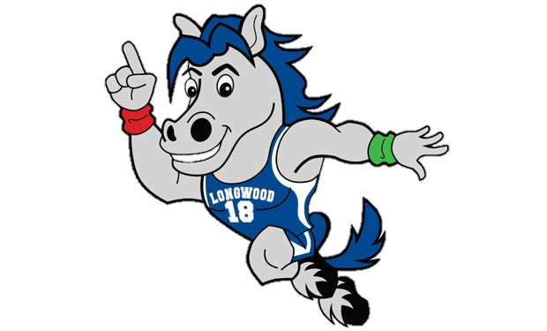

**PAYMENT AND DEADLINE**

A $100 NON-REFUNDABLE DEPOSIT MUST ACCOMPANY PAYMENT. FULL PAYMENT IS DUE 6/16/19. LATE REGISTRATION/PAYMENT WILL BE ACCEPTED UNTIL JUNE 16TH WITH A $10 ADDITIONAL CHARGE. REGSITRATION WILL END JUNE 16TH.

OVERNIGHT CAMPER BEFORE 6/10/19- $435.00

APPLICATION/DEPOSIT AFTER 6/10/19- $445.00

COMMUTER CAMPER BEFORE 6/10/19- $365.00

APPLICATION/DEPOSIT AFTER 6/10/19- $375.00

$50.00 DISCOUNT FOR FACULTY/STAFF OF LONGWOOD & MULTIPLE FAMILY MEMBERS

$35.00 DISCOUNT FOR TEAMS OF 7 OR MORE (MUST SIGN UP TOGETHER)

**PLEASE MAKE A CHECK PAYABLE TO:**

LONGWOOD SOFTBALL, LONGWOOD UNIVERSITY CAMP

C/O KAYLA MILLER

201 HIGH ST. TABB 220

FARMVILLE, VA 23909