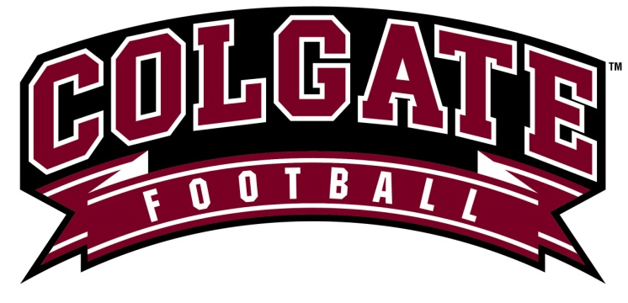

Colgate Football Camp 2019
June 16th – July 26th - July 27th

I hereby consent to the Directors and employees of Colgate One Day Football Camp acting for me according to their best judgment in any emergency requiring medical attention. I, for myself, my heirs, executors, and administrators, waive and release any claims against the camp instructors and the directors and the employees of Colgate Football Camp for all claims, injuries, damages, stolen or lost items, demands or actions whatsoever in any manner resulting from my traveling to and from or participating in the camp. I attest and verify that I am physically fit and have trained enough to participate in the camp and I have provided an Insurance Policy to the University and am fully aware that my Insurance Provider is responsible to cover all incidences occurring at camp that require its activation. Applicants need to check with their Coach or Athletic Director regarding eligibility and high school/NCAA compliance. I am also aware that I am financially responsible for any damage I cause to the Colgate University property and facilities.

Camper Name:_________________________________________________

Camper Signature: ______________________________________________ Date ___________________

Parent/Guardian Signature:_______________________________________ Date ___________________

Health Insurance Information

Insurance Provider ___________ ____________________________________________________________

Subscriber Name ________________________________ Subscriber ID _____________________________

Contact Info

Home Address ____________________________________________________________________

Cell Phone ________________________________

Email _____________________________

