Parking for Virginia Tech Baseball Camps:

Below is an image of campus on where to park:

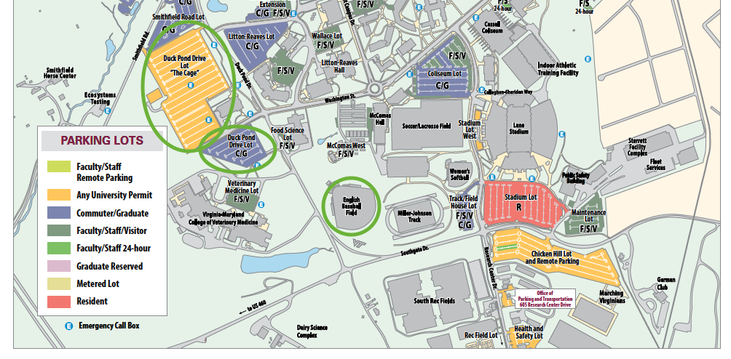

The two Duck Pond Lots (circled green lots on the left) are the most convenient lots to park in for camp at English Field. Parking on the weekend is free for camps that are held on the weekends.

